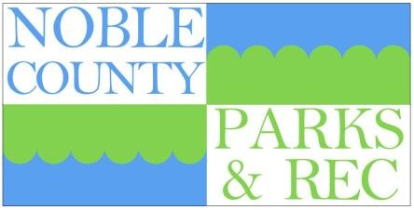
Noble County Parks and Recreation Board
Diann Scott, President
102 W 1050 N, Rome City, IN 46784
(260) 273-9441
Scottdianna103@gmail.com

NobleCoParks@gmail.com

Noble County Parks and Recreation Board
110 S. Orange Street (CVB/EDC Building) Albion, Indiana
August 28, 2024

Noble County Parks and Recreation Board Meeting Notes
Date: May 28, 2025
Location: Noble County Annex, York Street, Albion, IN
Board Members in Attendance:
- John Metzer
- Grace Caswell
Board Members Absent:
- Diann Scott
- Jim Haddock
- Chris Padilla
Guests Present:
- Ann Kline
- Tersea Tackett
- Kevin Yant
- Steve Hook
Meeting Summary:
John Metzer attempted to call the meeting to order; however, by 2:50 PM, a quorum had not been established due to insufficient board member attendance. As a result, the meeting was not opened.
Next Scheduled Meeting:
Date: June 25, 2025
Time: 2:30 PM
Please make every effort to attend, as establishing a quorum is essential for conducting official business.

John Metzger, VP | Grace Caswell, Secretary | Scott Allen | Chris Macias Padilla | James Haddock
4837 W 100 S | 110 S. Orange Street | 0171 S Old State Road 3 | . | 1201 Round Island Drive
Kimmell, IN 46760 | Albion, IN 46701 | Avilla, IN 46710 | Ligonier, IN 46767 | Kendallville, IN 46755
JohnMetzger1995@gmail.com | grace@visitnoblecounty.com | Scott.Allen.PE@gmail.com | cmacias@ligonier-IN.gov | Haddock@mchsi.com

